# **Cognizant Digital Nurture 4.0 - Week 7 ReactJS Hands-on Labs**

**Name:** Pranjal Yadav  
 **Roll Number:** 22052918  
 **Program:** DotNet Full Stack Engineer (FSE) Deep Skilling  
 **Week:** 7  
 **Technology:** ReactJS

## **Lab 1 – ReactJS-HOL 9: ES6 Features in React**

### **Objective:**

* Use map(), arrow functions, destructuring, merging arrays, and conditional rendering with JSX.

### **Code:**

**App.js**

import React from 'react';

import ListofPlayers from './ListofPlayers';

import IndianPlayers from './IndianPlayers';

function App() {

const flag = true;

return (

<div className="App">

<h1>Cricket Application</h1>

{flag ? <ListofPlayers /> : <IndianPlayers />}

</div>

);

}

export default App;

**ListofPlayers.js**

import React from 'react';

const ListofPlayers = () => {

const players = [

{ name: 'Virat Kohli', score: 85 },

{ name: 'Rohit Sharma', score: 92 },

{ name: 'KL Rahul', score: 65 },

{ name: 'Shubman Gill', score: 74 },

{ name: 'Hardik Pandya', score: 55 }

];

const lowScorers = players.filter(player => player.score < 70);

return (

<div>

<h2>All Players</h2>

<ul>

{players.map((player, index) => (

<li key={index}>{player.name} - {player.score}</li>

))}

</ul>

<h3>Players with score below 70</h3>

<ul>

{lowScorers.map((player, index) => (

<li key={index}>{player.name} - {player.score}</li>

))}

</ul>

</div>

);

};

export default ListofPlayers;

**IndianPlayers.js**

import React from 'react';

const IndianPlayers = () => {

const allPlayers = ['Virat', 'Rohit', 'Rahul', 'Gill', 'Pandya'];

const oddTeam = allPlayers.filter((_, i) => i % 2 !== 0);

const evenTeam = allPlayers.filter((_, i) => i % 2 === 0);

const T20Players = ['SKY', 'Tilak'];

const RanjiPlayers = ['Jaiswal', 'Sarfaraz'];

const allMerged = [...T20Players, ...RanjiPlayers];

return (

<div>

<h2>Even Team Players</h2>

<ul>{evenTeam.map((p, i) => <li key={i}>{p}</li>)}</ul>

<h2>Odd Team Players</h2>

<ul>{oddTeam.map((p, i) => <li key={i}>{p}</li>)}</ul>

<h2>Merged Players</h2>

<ul>{allMerged.map((p, i) => <li key={i}>{p}</li>)}</ul>

</div>

);

};

export default IndianPlayers;

📸 **Screenshot Placeholder:** Output for flag=true and flag=false

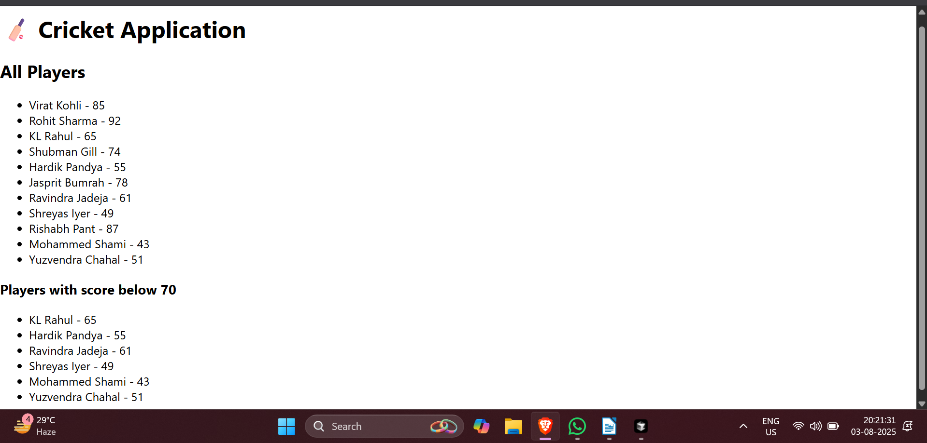

Output for flag=flase and flag=true

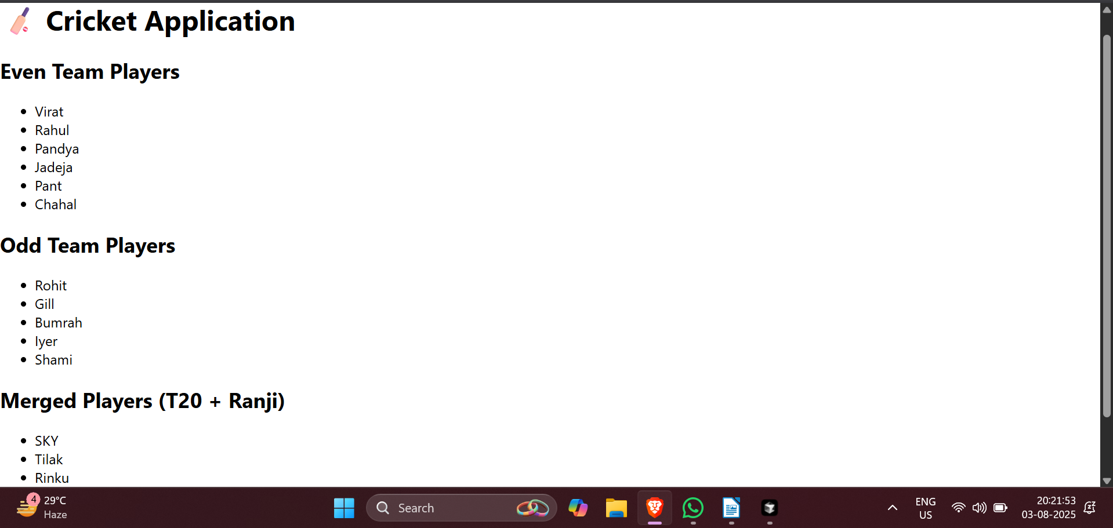

## **Lab 2 – ReactJS-HOL 10: JSX and Inline CSS**

### **Code:**

**App.js**

import React from 'react';

function App() {

const heading = <h1>🏢 Office Space Rental Listings</h1>;

const officeSpaces = [

{

id: 1,

name: 'Tech Park A',

rent: 75000,

address: 'Prestige Tech Park, MG Road, Bengaluru',

image: 'https://www.prestigesouthernstar.live/project/prestige-tech-park.webp'

},

{

id: 2,

name: 'Business Bay',

rent: 58000,

address: 'The Capital, BKC, Mumbai',

image: 'https://upload.wikimedia.org/wikipedia/commons/thumb/f/fe/TheCapital_Image2.jpg/250px-TheCapital_Image2.jpg'

},

{

id: 3,

name: 'Cyber Towers',

rent: 62000,

address: 'Cyber Towers, Hitech City, Hyderabad',

image: 'https://upload.wikimedia.org/wikipedia/commons/thumb/a/ab/Cyber_Towers_Madhapur_Hyderabad.jpg/1280px-Cyber_Towers_Madhapur_Hyderabad.jpg'

}

];

return (

<div className="App">

{heading}

<div style={{ display: 'flex', flexWrap: 'wrap', gap: '20px' }}>

{officeSpaces.map((office) => (

<div key={office.id} style={{

border: '1px solid #ccc', borderRadius: '10px', padding: '15px', width: '300px'

}}>

<img src={office.image} alt={office.name} style={{ width: '100%', height: '200px', objectFit: 'cover' }} />

<h3>{office.name}</h3>

<p><strong>Address:</strong> {office.address}</p>

<p style={{ color: office.rent < 60000 ? 'red' : 'green' }}>

<strong>Rent:</strong> ₹{office.rent}

</p>

</div>

))}

</div>

</div>

);

}

export default App;

📸 **Screenshot Placeholder:** Office listings with styled rent values

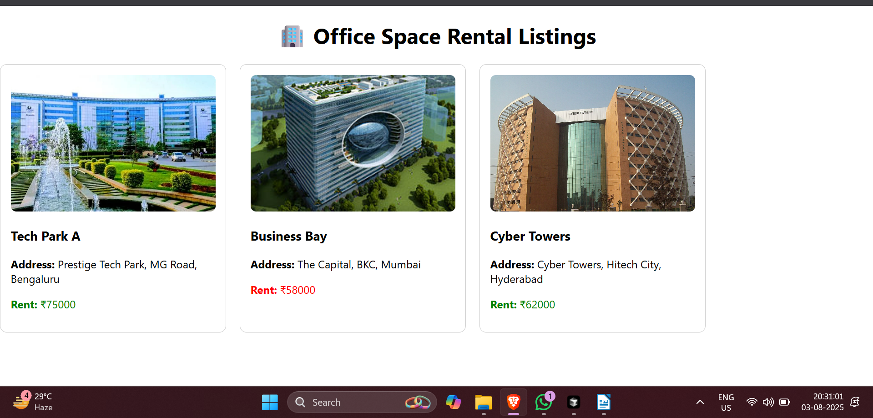

## ***Lab 3 – ReactJS-HOL 11: Event Handling***

### ***Code:***

***App.js***

*import React, { Component } from 'react';*

*import CurrencyConvertor from './CurrencyConvertor';*

*class App extends Component {*

*constructor(props) {*

*super(props);*

*this.state = { count: 0 };*

*this.increment = this.increment.bind(this);*

*this.sayHello = this.sayHello.bind(this);*

*this.handleClick = this.handleClick.bind(this);*

*}*

*increment() {*

*this.setState(prev => ({ count: prev.count + 1 }));*

*this.sayHello();*

*}*

*decrement = () => {*

*this.setState(prev => ({ count: prev.count - 1 }));*

*};*

*sayHello() {*

*alert("Hello! This is a static message from 'sayHello()'");*

*}*

*sayWelcome(msg) {*

*alert(msg);*

*}*

*handleClick(e) {*

*e.preventDefault();*

*alert("I was clicked (Synthetic Event)");*

*}*

*render() {*

*return (*

*<div>*

*<h1>Event Handling Example</h1>*

*<h2>Counter: {this.state.count}</h2>*

*<button onClick={this.increment}>Increase</button>*

*<button onClick={this.decrement}>Decrease</button><br/><br/>*

*<button onClick={() => this.sayWelcome("Welcome to React Events!")}>Say Welcome</button><br/><br/>*

*<button onClick={this.handleClick}>Synthetic Event Button</button><br/><br/>*

*<CurrencyConvertor />*

*</div>*

*);*

*}*

*}*

*export default App;*

***CurrencyConvertor.js***

*import React, { Component } from 'react';*

*class CurrencyConvertor extends Component {*

*constructor(props) {*

*super(props);*

*this.state = { rupees: '', euro: '' };*

*}*

*handleChange = (e) => {*

*this.setState({ rupees: e.target.value });*

*};*

*handleSubmit = (e) => {*

*e.preventDefault();*

*const euro = (this.state.rupees / 90).toFixed(2);*

*this.setState({ euro });*

*};*

*render() {*

*return (*

*<div>*

*<h2>Currency Convertor</h2>*

*<form onSubmit={this.handleSubmit}>*

*<label>₹ Rupees: </label>*

*<input type="number" value={this.state.rupees} onChange={this.handleChange} />*

*<button type="submit">Convert</button>*

*</form>*

*{this.state.euro && <p>€ Euro: {this.state.euro}</p>}*

*</div>*

*);*

*}*

*}*

*export default CurrencyConvertor;*

*📸* ***Screenshot Placeholder:*** *Event buttons and currency conversion output*

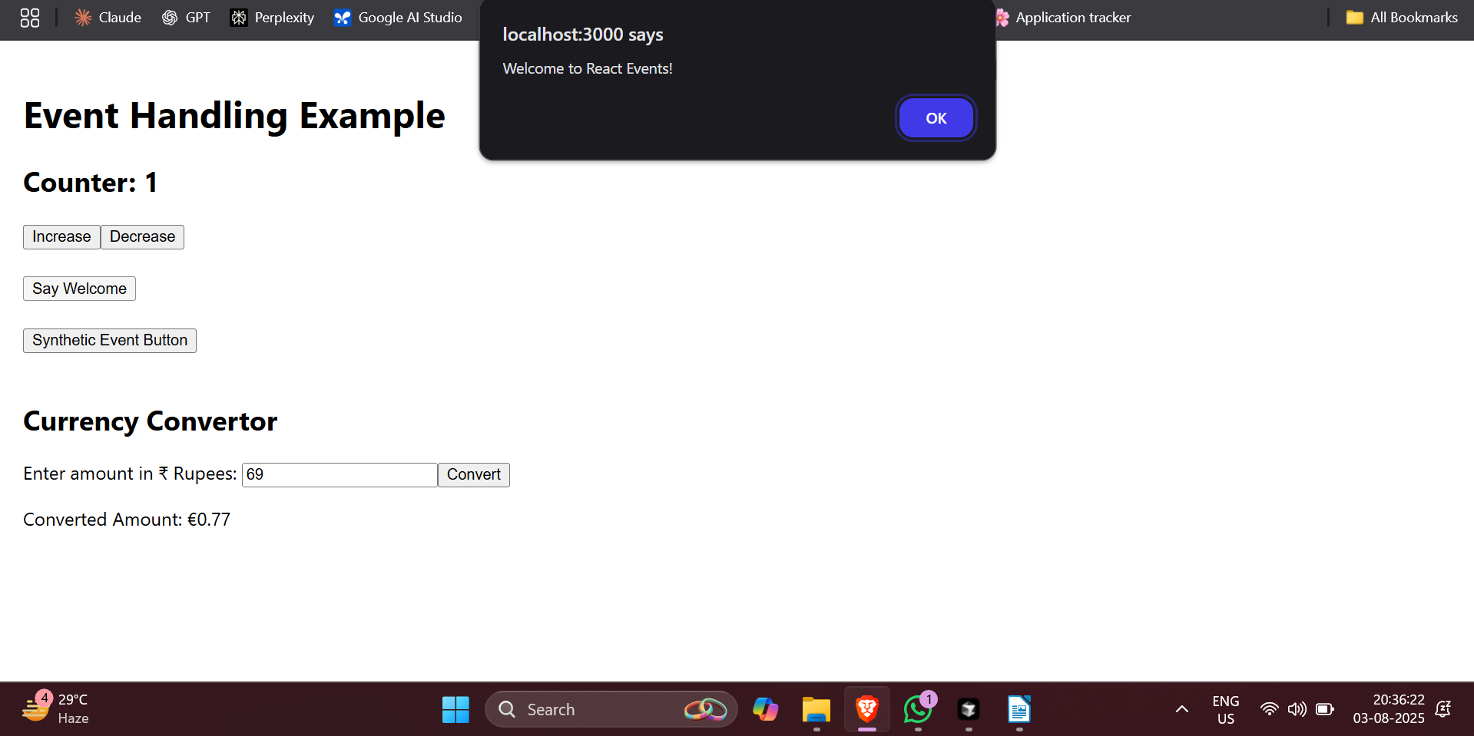

## ***Lab 4 – ReactJS-HOL 12: Conditional Rendering***

***App.js***

*import React, { Component } from 'react';*

*import Guest from './Guest';*

*import User from './User';*

*class App extends Component {*

*constructor(props) {*

*super(props);*

*this.state = { isLoggedIn: false };*

*}*

*handleLogin = () => this.setState({ isLoggedIn: true });*

*handleLogout = () => this.setState({ isLoggedIn: false });*

*render() {*

*return (*

*<div>*

*<h1>Ticket Booking App</h1>*

*{this.state.isLoggedIn ? <User onLogout={this.handleLogout} /> : <Guest onLogin={this.handleLogin} />}*

*</div>*

*);*

*}*

*}*

*export default App;*

***Guest.js***

*import React from 'react';*

*const Guest = ({ onLogin }) => (*

*<div>*

*<h2>Welcome, Guest!</h2>*

*<p>Browse flight listings:</p>*

*<ul>*

*<li>AI203 - Delhi to Mumbai</li>*

*<li>6E511 - Bengaluru to Hyderabad</li>*

*</ul>*

*<button onClick={onLogin}>Login</button>*

*</div>*

*);*

*export default Guest;*

***User.js***

*import React from 'react';*

*const User = ({ onLogout }) => (*

*<div>*

*<h2>Welcome, User!</h2>*

*<ul>*

*<li>AI203 - <button>Book</button></li>*

*<li>6E511 - <button>Book</button></li>*

*</ul>*

*<button onClick={onLogout}>Logout</button>*

*</div>*

*);*

*export default User;*

*📸* ***Screenshot Placeholder:*** *Guest vs Logged-in view toggle*

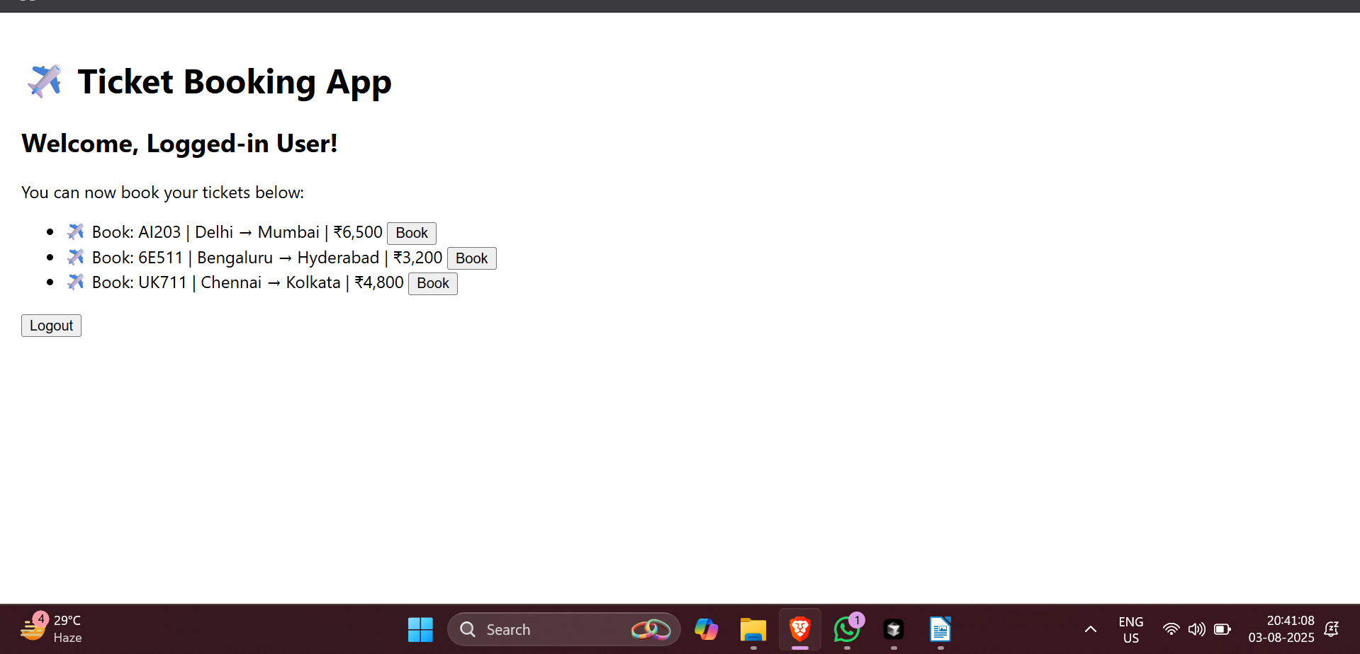

## ***Lab 5 – ReactJS-HOL 13: Conditional Rendering + Lists with Keys***

***App.js***

*import React from 'react';*

*import BookDetails from './BookDetails';*

*import BlogDetails from './BlogDetails';*

*import CourseDetails from './CourseDetails';*

*function App() {*

*return (*

*<div style={{ padding: '20px' }}>*

*<h1>📚 Blogger App Dashboard</h1>*

*<div style={{ display: 'flex', justifyContent: 'space-around' }}>*

*<div><CourseDetails /></div>*

*<div><BookDetails /></div>*

*<div><BlogDetails /></div>*

*</div>*

*</div>*

*);*

*}*

*export default App;*

***CourseDetails.js***

*import React from 'react';*

*const courses = [*

*{ id: 1, name: 'Angular', date: '4/5/2021' },*

*{ id: 2, name: 'React', date: '6/3/2021' }*

*];*

*const CourseDetails = () => (*

*<div>*

*<h2>Course Details</h2>*

*<ul>{courses.map(course => (*

*<li key={course.id}><strong>{course.name}</strong><br />{course.date}</li>*

*))}</ul>*

*</div>*

*);*

*export default CourseDetails;*

***BookDetails.js***

*import React from 'react';*

*const books = [*

*{ id: 1, title: 'Master React', price: 670 },*

*{ id: 2, title: 'Deep Dive into Angular 11', price: 800 },*

*{ id: 3, title: 'Mongo Essentials', price: 450 }*

*];*

*const BookDetails = () => (*

*<div>*

*<h2>Book Details</h2>*

*<ul>{books.map(book => (*

*<li key={book.id}><strong>{book.title}</strong><br />{book.price}</li>*

*))}</ul>*

*</div>*

*);*

*export default BookDetails;*

***BlogDetails.js***

*import React from 'react';*

*const blogs = [*

*{ id: 1, title: 'React Learning', author: 'Stephen Biz', content: 'Welcome to learning React!' },*

*{ id: 2, title: 'Installation', author: 'Schwezdenier', content: 'You can install React from npm.' }*

*];*

*const BlogDetails = () => (*

*<div>*

*<h2>Blog Details</h2>*

*<ul>{blogs.map(blog => (*

*<li key={blog.id} style={{ marginBottom: '15px' }}>*

*<strong>{blog.title}</strong><br /><em>{blog.author}</em><br />{blog.content}*

*</li>*

*))}</ul>*

*</div>*

*);*

*export default BlogDetails;*

*📸* ***Screenshot Placeholder:*** *All 3 components rendered side-by-side*

